Task on IAM

1.Create one IAM user and assign EC2 and S3 full access roles.
Go to aws console-search IAM usersgive username next.
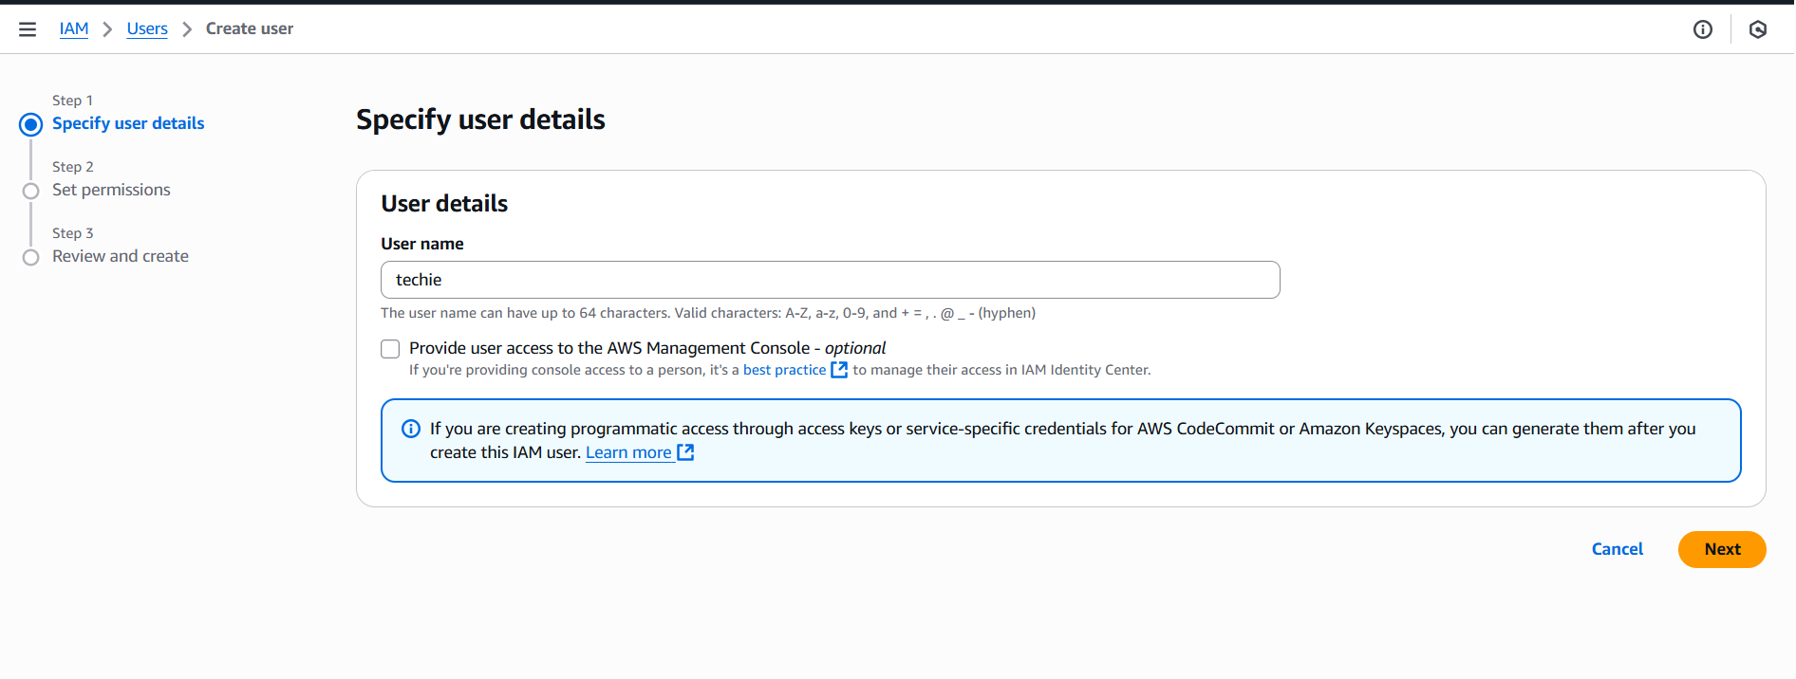
Give permissions to the user. For that we select ec2 and s3 full access.
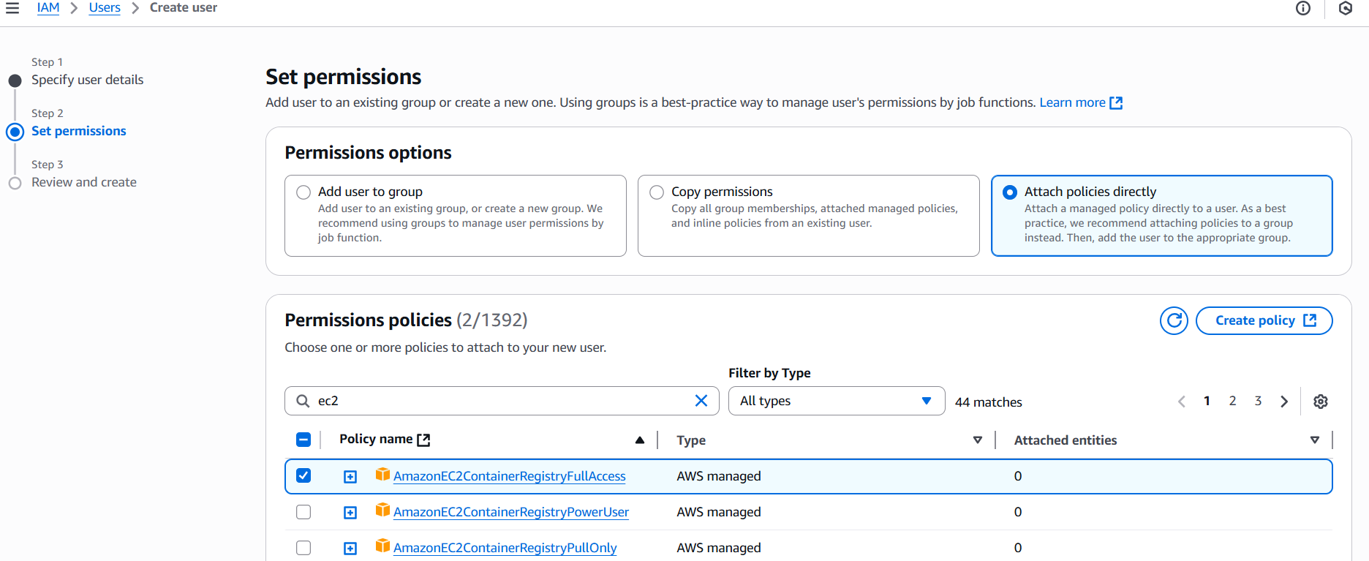

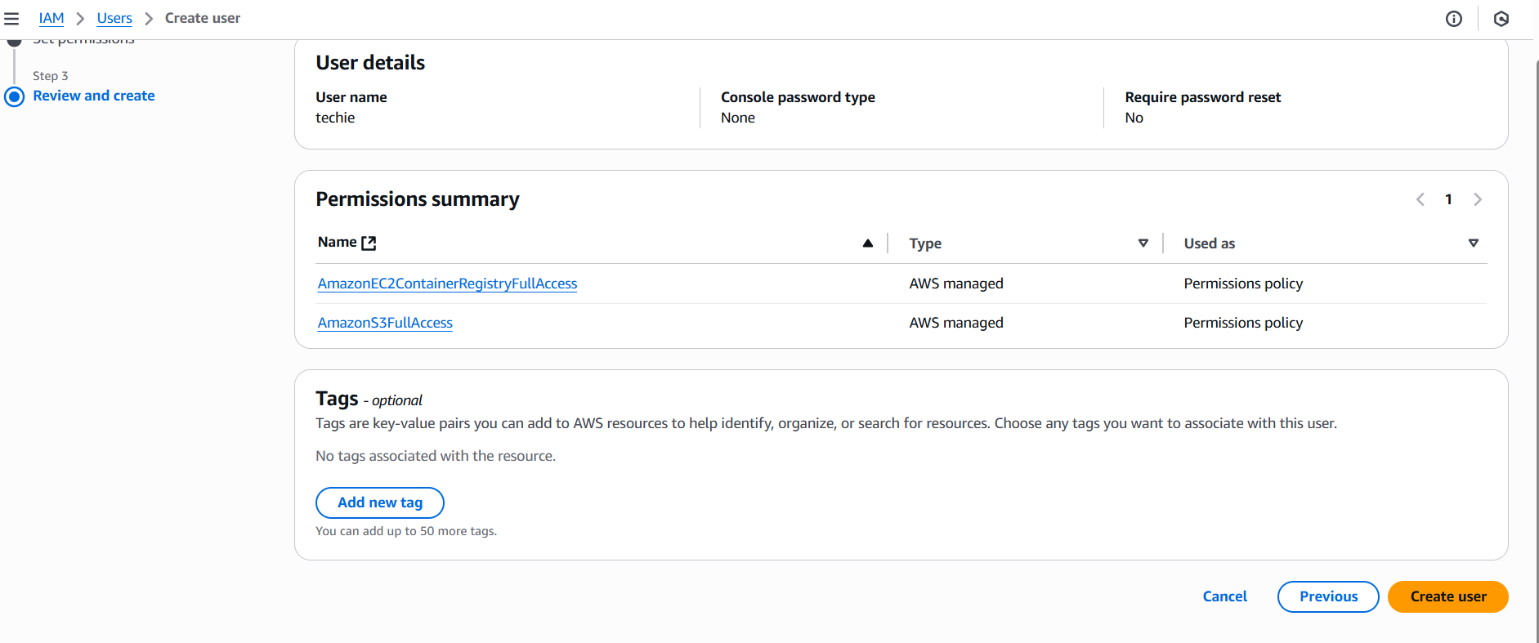
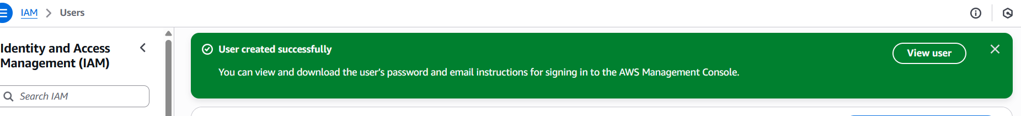2. Create one group in IAM and assign read access for EC2Navigate to IAM
In the search bar, type IAM and select it.
In the left sidebar, click User groups.
Create a New Group
Click Create group.
Enter a Group name (e.g., EC2ReadOnlyGroup).
Attach Permissions
Under Attach permissions policies, search for: AmazonEC2ReadOnlyAccess
Add the policy and check.

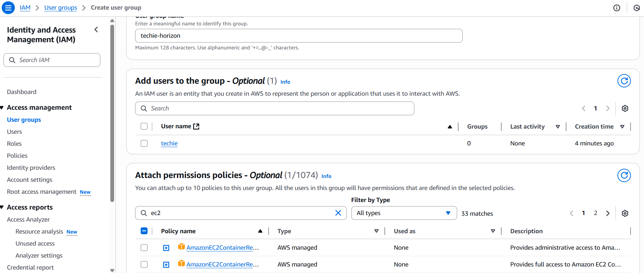
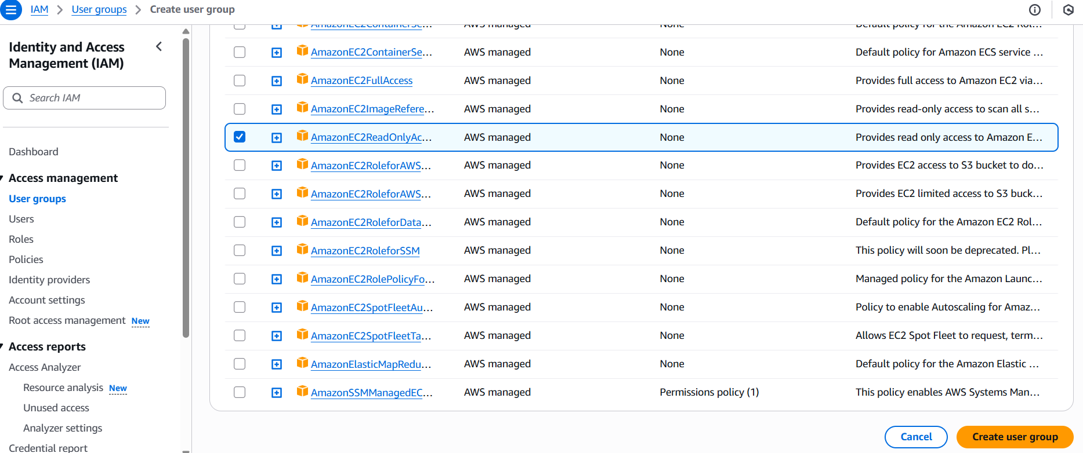
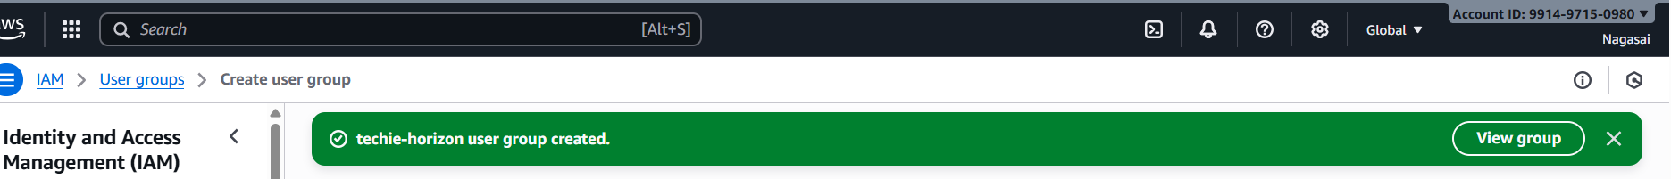3.Create a new user named "Devops" and add to the group created in task 2.
Login to root user of aws console.
Go to IAM services and click Users and create a user a devops
Attach the user to the existing group.
It will create an IAM user with existing access of the group we created
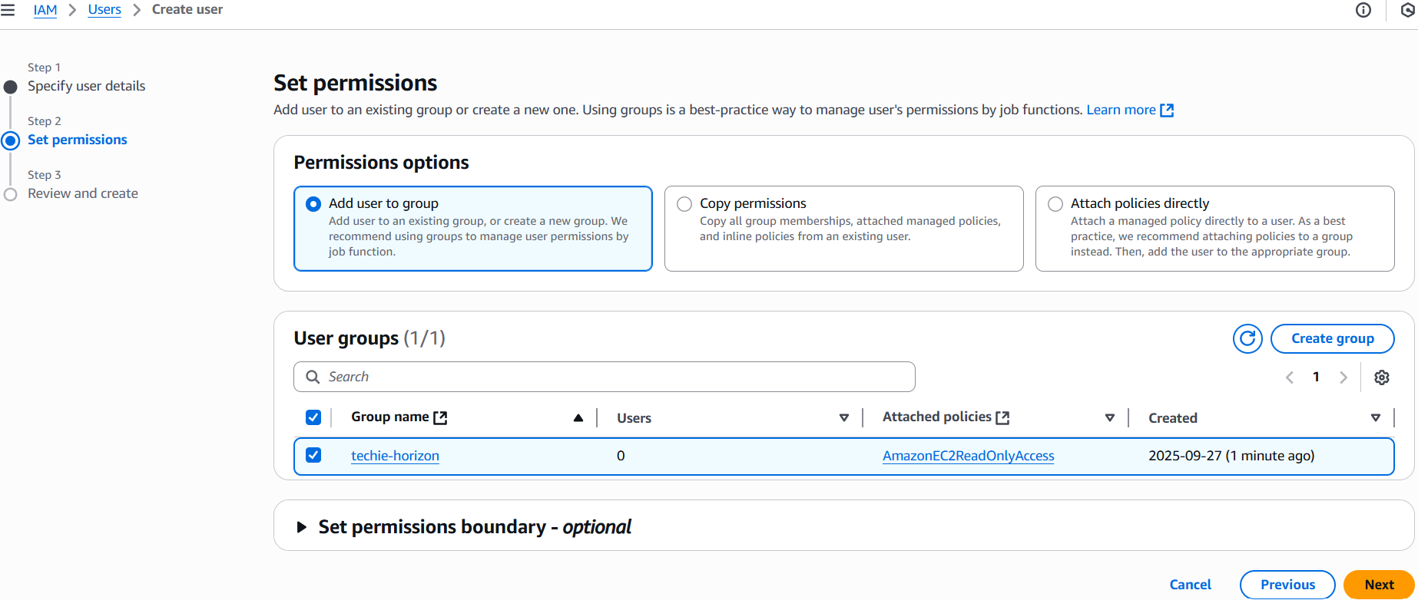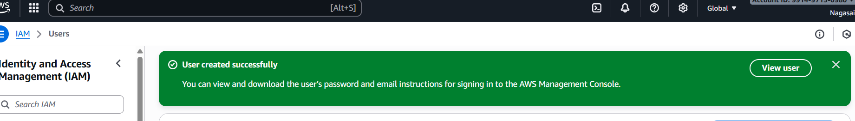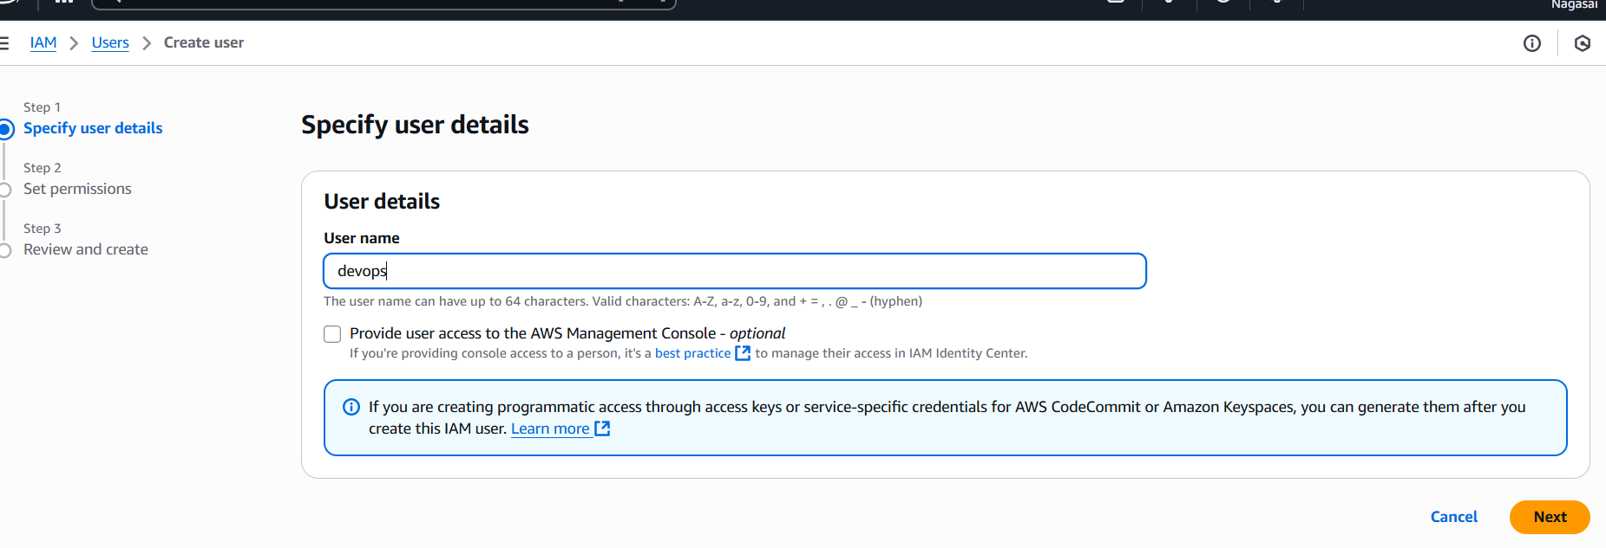

4.Write a bash script to create an IAM user with VPC full access.
Go to gitbash and configure aws account and write a bash script.
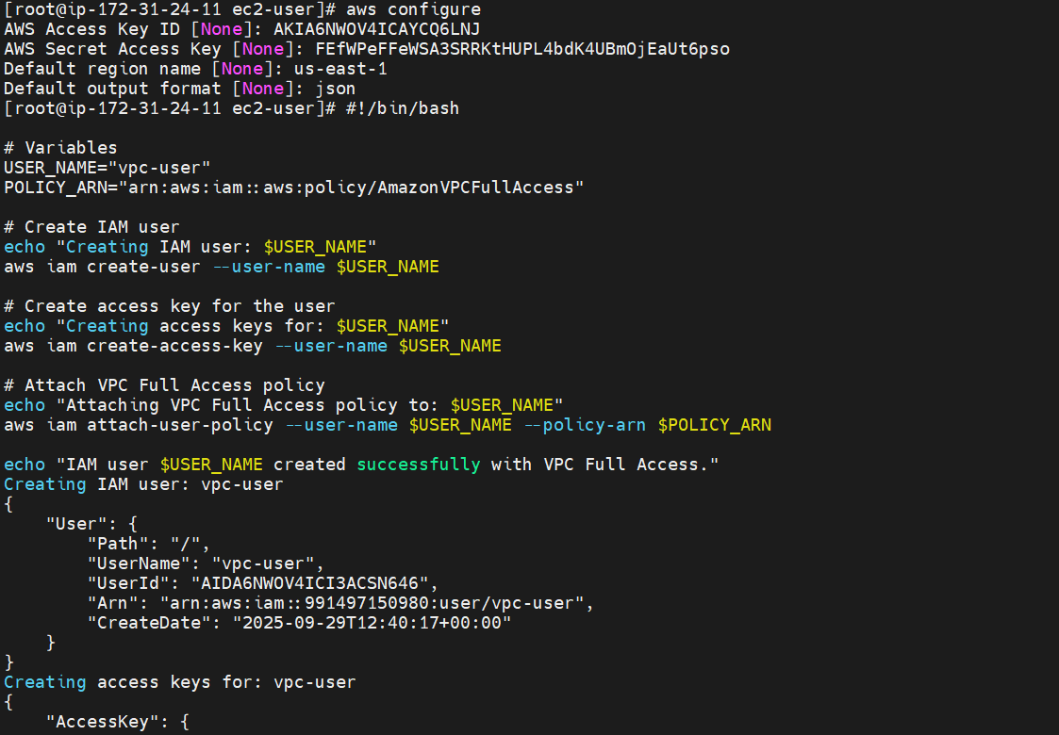
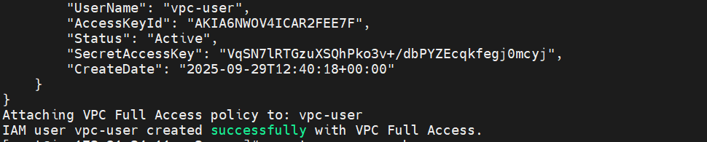
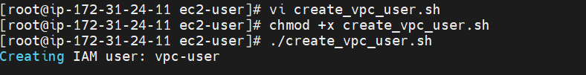
Go to iam services and successfully created a user.
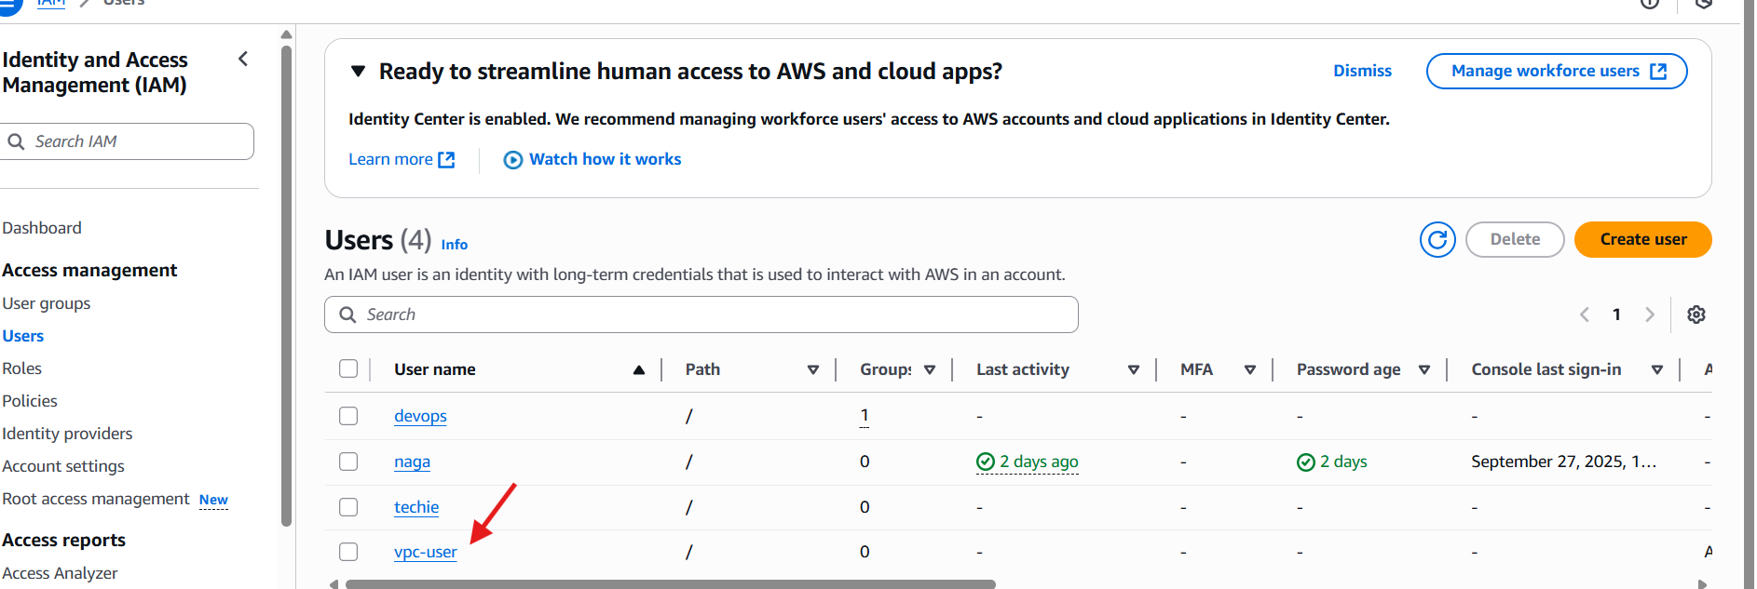
And also attach a vpc fullaccess.
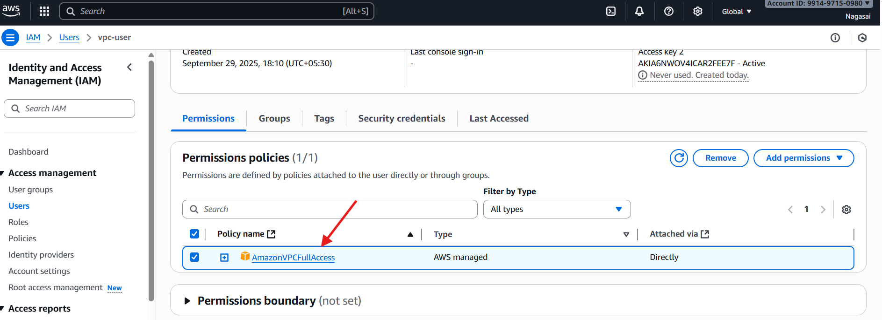
5.Create an IAM policy to allow EC2 access for a specific user in specific regions only.
Go to iam services and click on create policy.
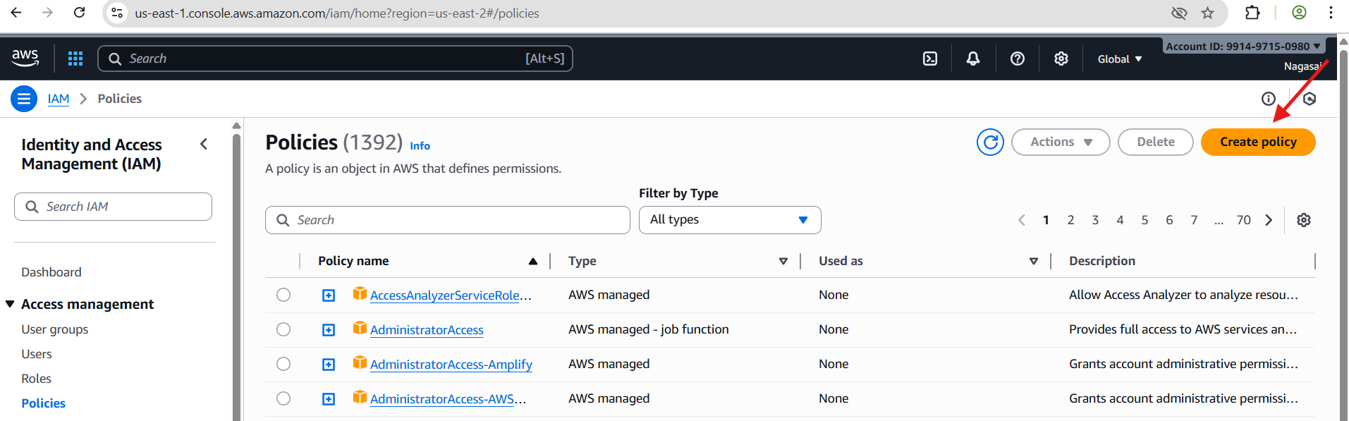
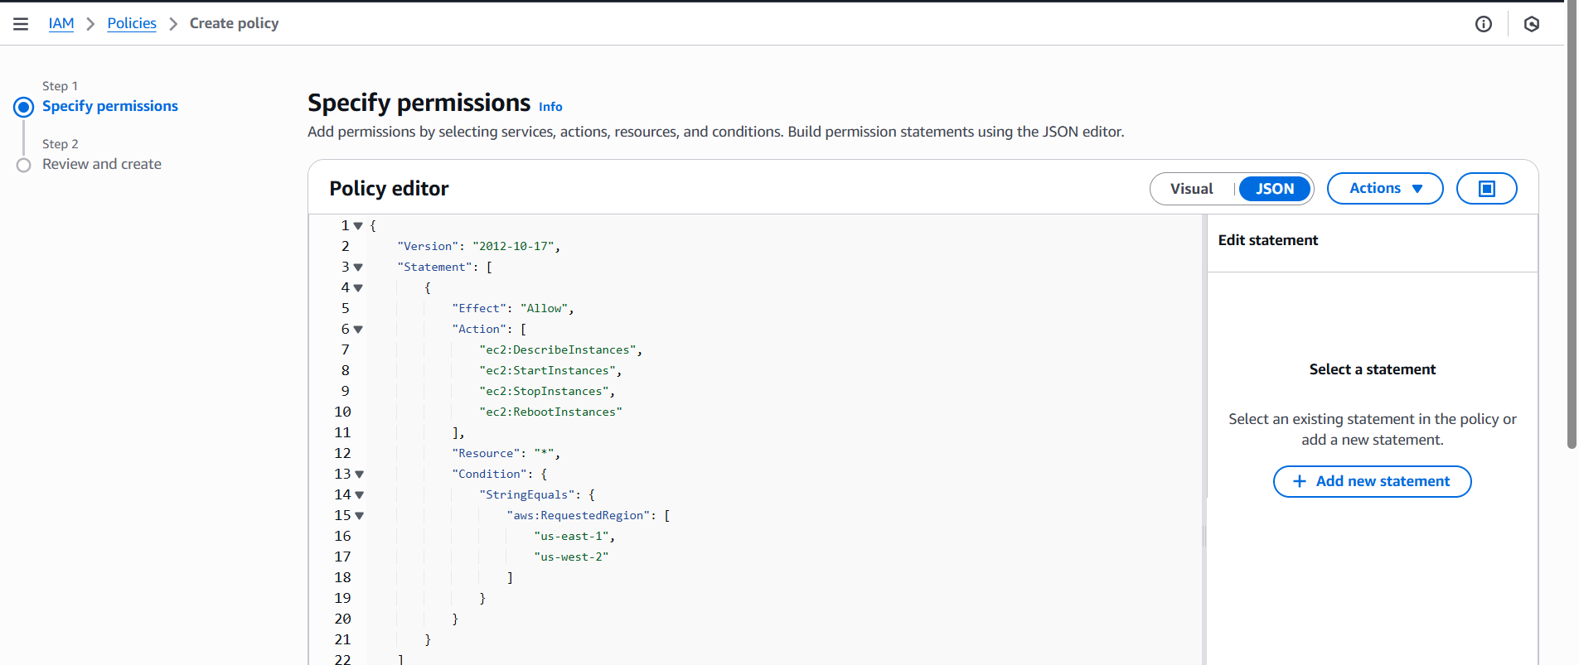
{
"Version": "2012-10-17",
"Statement": [
{
"Sid": "AllowEC2AccessInSpecificRegions",
"Effect": "Allow",
"Action": [
"ec2:DescribeInstances",
"ec2:StartInstances",
"ec2:StopInstances",
"ec2:RebootInstances",
"ec2:TerminateInstances",
"ec2:CreateTags",
"ec2:DescribeTags"
],
"Resource": "*",
"Condition": {
"StringEquals": {
"aws:RequestedRegion": [
"us-east-1",
"us-west-2"
]
}
}
}
]
}
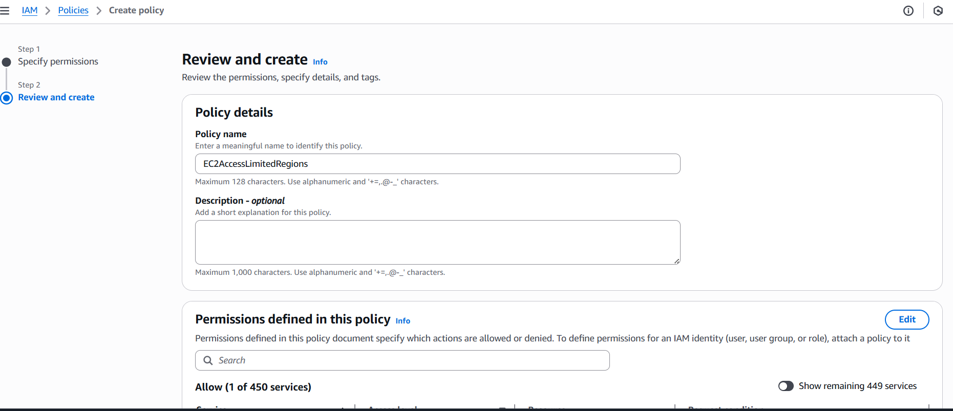
And also attach a policy to user naga .
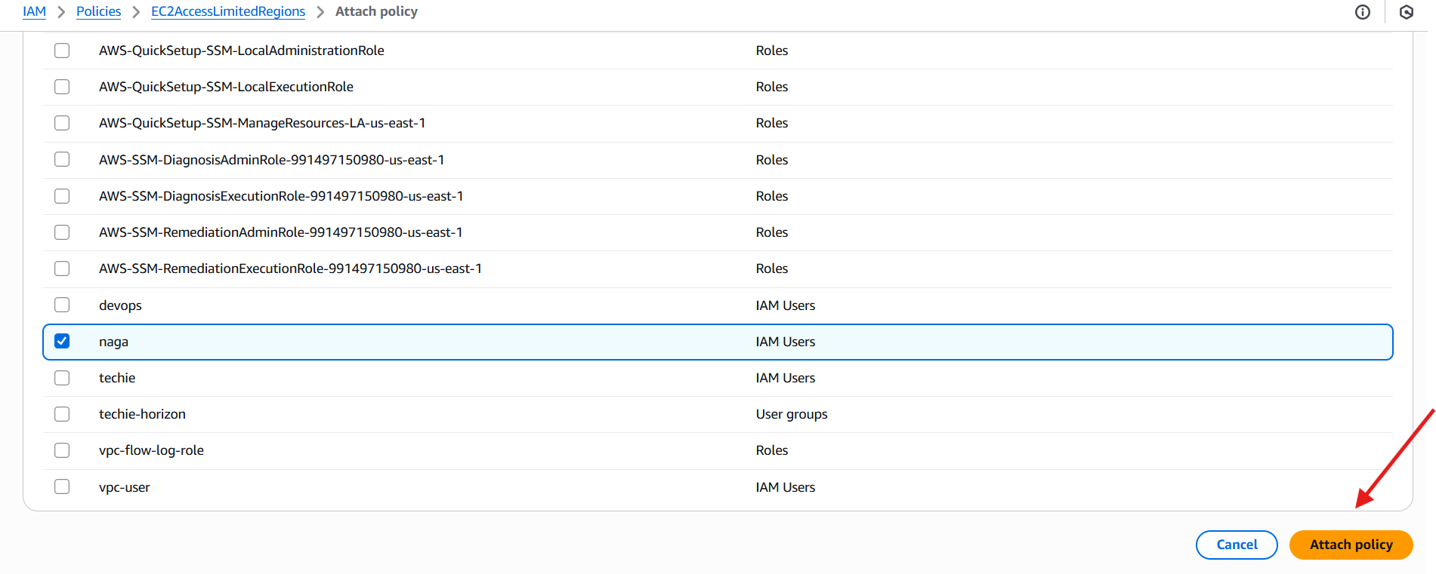
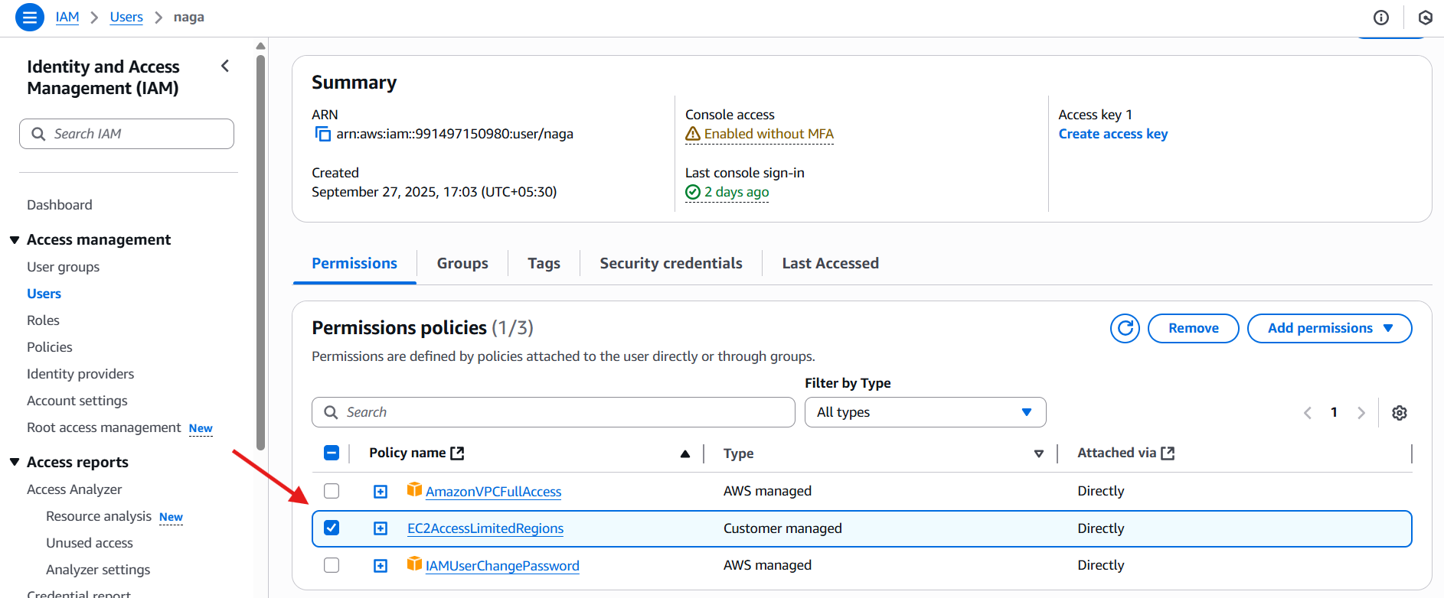
6.We have two accounts: Account A and Account B. Account A user should access an S3 bucket in Account B.
